**PRATIKUM PEMROGRAMAN II**

**TUGAS - 6**



Disusun Oleh :

Muhammad Fauzan Dwi Putera (223040033)

**Kelas A**

**Teknik Informatika**

**Fakultas Teknik**

**Universitas Pasundan**

**A. File (MainApp.java)**

import java.awt.*;

import javax.swing.*;

public class MainApp extends JFrame {

    public MainApp() {

        // Set title and default close operation

        setTitle("Aplikasi Java dengan Multi Form");

        setDefaultCloseOperation(JFrame.EXIT_ON_CLOSE);

        setSize(800, 600);

        setLocationRelativeTo(null);

        // Create menu bar

        JMenuBar menuBar = new JMenuBar();

        JMenu menu = new JMenu("Menu");

        JMenuItem menuItem1 = new JMenuItem("Form Input 1");

        JMenuItem menuItem2 = new JMenuItem("Form Input 2");

        menu.add(menuItem1);

        menu.add(menuItem2);

        menuBar.add(menu);

        setJMenuBar(menuBar);

        // Main panel with CardLayout for switching between forms

        JPanel mainPanel = new JPanel(new CardLayout());

        // Create and add Form 1 and Form 2 to main panel

        JPanel formPanel1 = new FormPanel1();

        JPanel formPanel2 = new FormPanel2();

        mainPanel.add(formPanel1, "Form Input 1");

        mainPanel.add(formPanel2, "Form Input 2");

        // Add action listeners for menu items to switch forms

        menuItem1.addActionListener(e -> showForm(mainPanel, "Form Input 1"));

        menuItem2.addActionListener(e -> showForm(mainPanel, "Form Input 2"));

        // Add main panel to frame

        add(mainPanel);

        setVisible(true);

    }

    private void showForm(JPanel mainPanel, String formName) {

        CardLayout cl = (CardLayout) mainPanel.getLayout();

        cl.show(mainPanel, formName);

    }

    public static void main(String[] args) {

        SwingUtilities.invokeLater(MainApp::new);

    }

}

**B. File (FormPanel1)**

import java.awt.*;

import javax.swing.*;

import javax.swing.table.DefaultTableModel;

public class FormPanel1 extends JPanel {

    private JTextField textField;

    private JTextArea textArea;

    private JRadioButton radioButton1, radioButton2;

    private JCheckBox checkBox;

    private JComboBox<String> comboBox;

    private JList<String> list;

    private JSlider slider;

    private JSpinner spinner;

    private JTable table;

    private DefaultTableModel tableModel;

    public FormPanel1() {

        setLayout(new BorderLayout());

        // Panel untuk memasukkan komponen input

        JPanel inputPanel = new JPanel();

        inputPanel.setLayout(new GridLayout(9, 2, 5, 5));

        // JTextField

        inputPanel.add(new JLabel("Text Field:"));

        textField = new JTextField();

        inputPanel.add(textField);

        // JTextArea

        inputPanel.add(new JLabel("Text Area:"));

        textArea = new JTextArea(3, 20);

        inputPanel.add(new JScrollPane(textArea));

        // JRadioButton

        inputPanel.add(new JLabel("Radio Button:"));

        radioButton1 = new JRadioButton("Option 1");

        radioButton2 = new JRadioButton("Option 2");

        ButtonGroup group = new ButtonGroup();

        group.add(radioButton1);

        group.add(radioButton2);

        JPanel radioPanel = new JPanel();

        radioPanel.add(radioButton1);

        radioPanel.add(radioButton2);

        inputPanel.add(radioPanel);

        // JCheckBox

        inputPanel.add(new JLabel("Check Box:"));

        checkBox = new JCheckBox("Agree?");

        inputPanel.add(checkBox);

        // JComboBox

        inputPanel.add(new JLabel("Combo Box:"));

        comboBox = new JComboBox<>(new String[] { "Option 1", "Option 2", "Option 3" });

        inputPanel.add(comboBox);

        // JList

        inputPanel.add(new JLabel("List:"));

        list = new JList<>(new String[] { "Item 1", "Item 2", "Item 3" });

        inputPanel.add(new JScrollPane(list));

        // JSlider

        inputPanel.add(new JLabel("Slider:"));

        slider = new JSlider(0, 100, 50);

        inputPanel.add(slider);

        // JSpinner

        inputPanel.add(new JLabel("Spinner:"));

        spinner = new JSpinner(new SpinnerNumberModel(1, 1, 10, 1));

        inputPanel.add(spinner);

        // Panel untuk menampung input dan tombol

        add(inputPanel, BorderLayout.CENTER);

        // JTable

        String[] columns = { "Field", "Value" };

        tableModel = new DefaultTableModel(columns, 0);

        table = new JTable(tableModel);

        add(new JScrollPane(table), BorderLayout.SOUTH);

        // Button to add input data to table

        JButton addButton = new JButton("Add to Table");

        addButton.addActionListener(e -> addToTable());

        add(addButton, BorderLayout.NORTH);

    }

    private void addToTable() {

        tableModel.addRow(new Object[] { "TextField", textField.getText() });

        tableModel.addRow(new Object[] { "TextArea", textArea.getText() });

        tableModel.addRow(new Object[] { "RadioButton", radioButton1.isSelected() ? "Option 1" : "Option 2" });

        tableModel.addRow(new Object[] { "CheckBox", checkBox.isSelected() ? "Checked" : "Unchecked" });

        tableModel.addRow(new Object[] { "ComboBox", comboBox.getSelectedItem().toString() });

        tableModel.addRow(new Object[] { "List", list.getSelectedValue() });

        tableModel.addRow(new Object[] { "Slider", slider.getValue() });

        tableModel.addRow(new Object[] { "Spinner", spinner.getValue() });

    }

}

**C. File (FormPanel2)**

import java.awt.*;

import javax.swing.*;

import javax.swing.table.DefaultTableModel;

public class FormPanel2 extends JPanel {

    private JTextField textField;

    private JTextArea textArea;

    private JRadioButton radioButton1, radioButton2;

    private JCheckBox checkBox;

    private JComboBox<String> comboBox;

    private JList<String> list;

    private JSlider slider;

    private JSpinner spinner;

    private JTable table;

    private DefaultTableModel tableModel;

    public FormPanel2() {

        setLayout(new BorderLayout());

        // Panel untuk memasukkan komponen input

        JPanel inputPanel = new JPanel();

        inputPanel.setLayout(new GridLayout(9, 2, 5, 5));

        // JTextField

        inputPanel.add(new JLabel("Text Field:"));

        textField = new JTextField();

        inputPanel.add(textField);

        // JTextArea

        inputPanel.add(new JLabel("Text Area:"));

        textArea = new JTextArea(3, 20);

        inputPanel.add(new JScrollPane(textArea));

        // JRadioButton

        inputPanel.add(new JLabel("Radio Button:"));

        radioButton1 = new JRadioButton("Option 1");

        radioButton2 = new JRadioButton("Option 2");

        ButtonGroup group = new ButtonGroup();

        group.add(radioButton1);

        group.add(radioButton2);

        JPanel radioPanel = new JPanel();

        radioPanel.add(radioButton1);

        radioPanel.add(radioButton2);

        inputPanel.add(radioPanel);

        // JCheckBox

        inputPanel.add(new JLabel("Check Box:"));

        checkBox = new JCheckBox("Agree?");

        inputPanel.add(checkBox);

        // JComboBox

        inputPanel.add(new JLabel("Combo Box:"));

        comboBox = new JComboBox<>(new String[] { "Option 1", "Option 2", "Option 3" });

        inputPanel.add(comboBox);

        // JList

        inputPanel.add(new JLabel("List:"));

        list = new JList<>(new String[] { "Item 1", "Item 2", "Item 3" });

        inputPanel.add(new JScrollPane(list));

        // JSlider

        inputPanel.add(new JLabel("Slider:"));

        slider = new JSlider(0, 100, 50);

        inputPanel.add(slider);

        // JSpinner

        inputPanel.add(new JLabel("Spinner:"));

        spinner = new JSpinner(new SpinnerNumberModel(1, 1, 10, 1));

        inputPanel.add(spinner);

        // Panel untuk menampung input dan tombol

        add(inputPanel, BorderLayout.CENTER);

        // JTable

        String[] columns = { "Field", "Value" };

        tableModel = new DefaultTableModel(columns, 0);

        table = new JTable(tableModel);

        add(new JScrollPane(table), BorderLayout.SOUTH);

        // Button to add input data to table

        JButton addButton = new JButton("Add to Table");

        addButton.addActionListener(e -> addToTable());

        add(addButton, BorderLayout.NORTH);

    }

    private void addToTable() {

        tableModel.addRow(new Object[] { "TextField", textField.getText() });

        tableModel.addRow(new Object[] { "TextArea", textArea.getText() });

        tableModel.addRow(new Object[] { "RadioButton", radioButton1.isSelected() ? "Option 1" : "Option 2" });

        tableModel.addRow(new Object[] { "CheckBox", checkBox.isSelected() ? "Checked" : "Unchecked" });

        tableModel.addRow(new Object[] { "ComboBox", comboBox.getSelectedItem().toString() });

        tableModel.addRow(new Object[] { "List", list.getSelectedValue() });

        tableModel.addRow(new Object[] { "Slider", slider.getValue() });

        tableModel.addRow(new Object[] { "Spinner", spinner.getValue() });

    }

}

**Penjelasan**

1. **File MainApp.java**: Ini adalah kelas utama yang mengelola seluruh aplikasi dan membuat navigasi antara form 1 dan form 2. Form 2 dipanggil sebagai instance dari kelas FormPanel2.
2. **File FormPanel2.java**

: Ini adalah form kedua yang ditambahkan ke aplikasi utama. FormPanel2 dibuat dengan layout sederhana yang terdiri dari sebuah label, JTextField, dan tombol submit.

**Cara Kerja**

* MainApp mengatur CardLayout dan menu untuk navigasi antara Form 1 dan Form 2.
* Ketika pengguna memilih "Form Input 2" dari menu, aplikasi akan menampilkan form yang dibuat di FormPanel2.

**Outputnya :**

* + Form 1

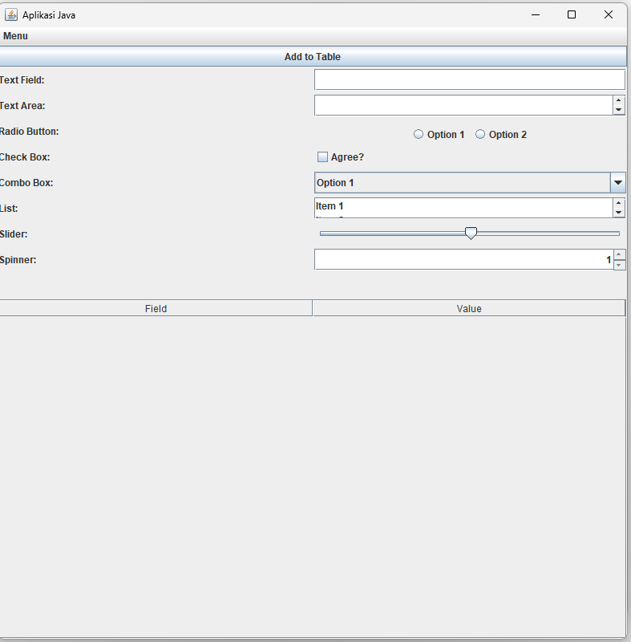

* + 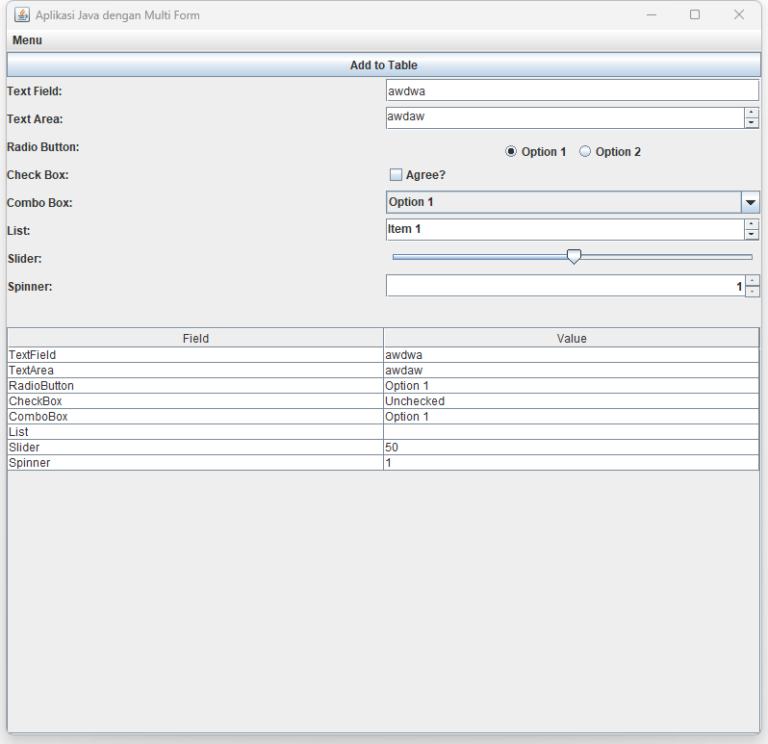Form 2 :

Link Github :

<https://github.com/Fauzan2617/pp2_223040033_A/tree/main/Tugas%206>